PE Funding

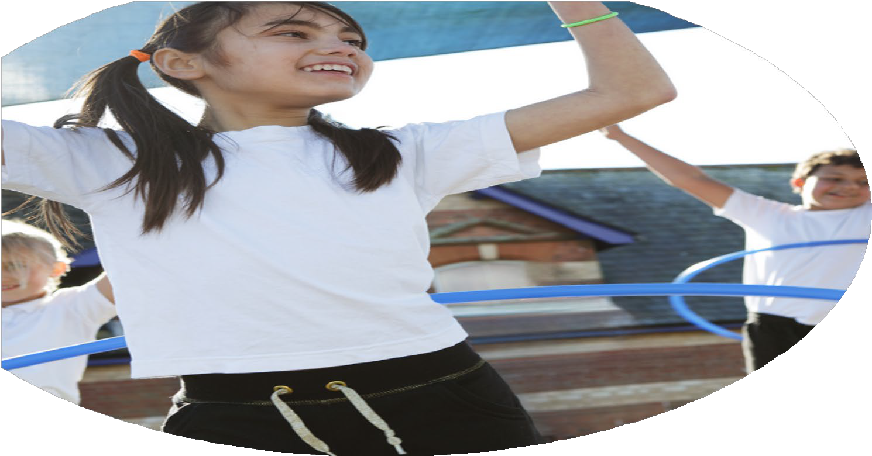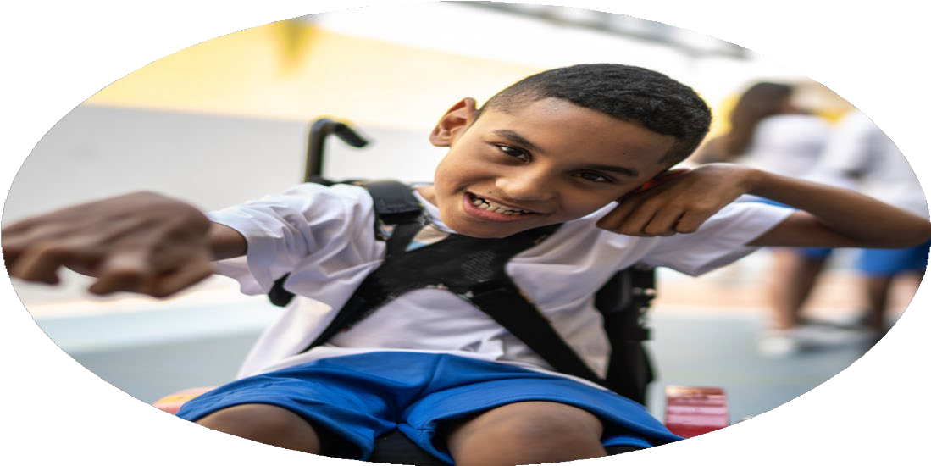

Evaluation Form

**Commissioned by**

**Created by**

Images courtesy of Youth Sport Trust

**PE Funding Evaluation Form**

 It is intended that this template should be used as preparation for the completion of the statutory digital reporting tool being introduced this academic year. You can upload data (including swimming) from this template onto this platform once it becomes accessible.

 Before you decide how you are going to use the funding for this academic year you should reflect and evaluate the impact of your use of the funding in 2023/24.

 All spending of the funding must conform with the terms outlined in the Conditions of Grant document.  The template is a working document that you can amend/update during the year.

 Based on your evaluation of last year’s funding you should decide what you intend to do this academic year, how you will do it, and what impact you expect it to have.

It is important that the funding is used effectively and based on your school’s needs.

 You must use the funding to make additional and sustainable improvements to the PE and sport in your school.  You must develop and add to the PESSPA activities that your school already offers.

Key Indicators – colour coded for use in document:

1. Increasing confidence, knowledge and skills of all staff in teaching PE and sporting activities

2. Increasing engagement of all pupils in regular physical activity and sporting activities

3. Raising the profile of PE and sport across the school, to support whole school improvement

4. Offer a broader and more equal experience of a range of sports and physical activities to all pupils

5. Increasing participation in competitive sport

*Summative digital reporting from June 2025 will continue to include swimming and water safety information therefore funding can be used to provide top-up lessons where necessary to ensure pupils meet national curriculum swimming requirements.*

**We recommend that you start by reflecting on the impact of current provision and reviewing your previous spend**

|  |  |  |  |
| --- | --- | --- | --- |
| What went well? | How do you know? | What didn’t go well? | How do you know? |
| Lunchtime activity rota created to ensure all children are engage in physical activity and sport. Activities designed to allow children to develop their fundamental movement skills as well and physical literacy.  Subscription to Cross Curricular Orienteering  to encourage active lessons in all areas of the curriculum.  80% of KS2 children across the school taken part in an intra-house/virtual/inter-house competition throughout the academic year  Teacher CPD- Hertfordshire Cricket delivered Chance to Shine programme to the children and teaching staff included.  Teach Active Training session  Wider range of sports clubs/session/interventions offered after-school and during lunchtimes  including clubs targeting SEND  Achieved Gold in the school games Mark 2024 | Activity levels at lunchtimes improved.  Sports Leaders supporting the MSA’s at lunchtime and delivering games and activities.  MSA handing out Teamwork stickers to children identified as showing great teamwork in their activity.  Positive pupil feedback from other  curriculum areas where ‘Cross Curricular  Orienteering’ used.  Monitor and tracking form  Large number of children attended the cricket afterschool club. Teacher learnt new skills and ideas for when teaching cricket. Pupil voice and staff voice shared and pupils would like programme to continue next academic year 25-26.  Teacher Active embedded into the school curriculum and teacher encouraged to use to support kinesthetic and active learning.  Increase in number of boys and girls attending football club which resulted in a junior team being entered into the league. Increase in year 3/4 girls taking part in a range of engage and inspire football events.  Celebrated by the SGO | KS1 Children unable to use the scooters correctly- Training on scooters to be delivered to ensure children leaving KS1 can correctly use the scooters.  Cross Curricular Orienteering could be used even more. Cards placed around the school damaged or weathered away.  20% of KS1 children only took part intra-house/virtual/inter-house competition  Staff were unable to do a lot of active teaching during the winter months due to weather and space.  Communicating with other schools to develop competitions for Key Stage 1 children. | Staff Voice  Medical tracker logs  Behaviour Logs  Not used in all areas subject areas.  Monitor and tracking form and not as many opportunities for KS1 children.  Teacher feedback  Through learning walks  Lesson plans  Pupil voice  Pupil Voice |

|  |  |
| --- | --- |
| What are your plans for 2024/25? | How are you going to action and achieve these plans? |
| Intent | Implementation |
| Continue to engage children in physical activity during lunch times and break times, to aim to achieve more than 30 minutes of activity outside of PE lessons per day.  To raise the profile of the links between sports, physical activity and healthy lifestyles across school.  Continue to access a wide range of inter-school competitions and hold regular intra-school events  To raise teacher confidence especially ECT when teaching PE  Increased participation in the number of sporting events entered and events being delivered by other local sports organisation other than the sports partnership.  Continue to raise the profile of sports and physical activity. | Increase the number of intra and inter-house competitions attended  Continue to develop the lunchtime activities rota  CPD for MSA’s  Share and promote sporting achievement whether for the school or outside of school during achievement assemblies  Continue to invite guest speakers in to deliver workshop/sessions  Healthy Eating Workshops, Love Your Heart Month, Action Mat Workshop, Just Talk Week, Walk To School Week, Fit Kidz Workshops, Guest Speakers, Scooterbility/Bikeability, Mental Wellbeing Workshop, Children Mental Health Week, National Fitness Week, Stevenage Borough Football Joy and Learn sessions, Curriculum evening, Science Week, Pedestrian Training, Swimming assembly/ Team GB Workshop/ NSPCC Fun Run, National Sports Week, DIPPS Training, Schools Football Week, KS1 Action Mats workshop  Continue to be member of SSFT  Host events at the school  Network with other sporting organisation e.g. SBFC  Staff voice, learning walks, team teaching, CPD if and when required  Engage KS1 children in more sporting events. Contact SBFC about events they will be hosting throughout the year.  Network with key stage holders, share updates on social media and newsletter. Invite in guest speaker, increase workshops delivered by inspirational figures. |

|  |  |
| --- | --- |
| What impact/intended impact/sustainability are you  expecting? | How will you know? What **evidence** do you have or  expect to have? |
| Continued success in inter-school sports events  Increase in % of participation in inter-school events  Continued development of intra-school competitions  Teacher confidence in the teaching of PE increased, which will then lead to high quality teaching and learning  More active minutes to enable the children to achieve more than 30 active minutes in school per day  Continued high levels of engagement from children in clubs and sports festivals  Continue to raise the profile of sports and physical activity. | Participation data  Photos  Pupil voice  Pupil voice  Learning walks  Staff voice  Pupil feedback  Learning walks of active lessons  Book scrutiny of active lessons  Walk To School Week  Active Travel- Herts Travel Advisor  Number of clubs being delivered  Participation data of club  Pupil voice  Staff voice  Achieve Gold in the School Games Mark to then work towards the Platinum Award  Modeshift Award  Inclusion Quality Mark  KS1 School Games Mark  Active Lives Children and Young People Survey |

**Swimming Data**

*Meeting National Curriculum requirements for swimming and water safety.*

*Priority should always be given to ensuring that pupils can perform safe self-rescue even if they do not fully meet the first two requirements of the National Curriculum programme of study*

|  |  |  |
| --- | --- | --- |
| **Question** | **Stats:** | **Further context**  **Relative to local challenges** |
| What percentage of your current Year 6 cohort can swim competently, confidently and proficiently over a distance of at least 25 metres? | 80% |  |
| What percentage of your current Year 6 cohort can use a range of strokes effectively [for example, front crawl, backstroke, and breaststroke]? | 80% |  |
| What percentage of your current Year 6 cohort are able to perform safe self-rescue in different water-based situations? | 80% |  |
| If your schools swimming data is below national expectation, you can choose to use the Primary PE and sport premium to provide additional top-up sessions for those pupils that did not meet National Curriculum requirements after the completion of core lessons. Have you done this? | Yes/No |  |
| Have you provided CPD to improve the knowledge and confidence of staff to be able to teach swimming and water safety? | Yes/No |  |

|  |  |
| --- | --- |
| What **impact/sustainability** have you seen? | What **evidence** do you have? |
| Stevenage Together Award 2024- Raised the profile of PE, SS, PA across the town. High Court Sherriff attended a PE session. PE lead invited to deliver at a PE conference in a different county where the school was praised for its’ commitment to PE, SS and PA. Inclusivity Workshop-As part of our Inclusivity Quality Mark, DW will be delivering a presentation about inclusivity in sports and how it is factored into our PE curriculum.  Stevenage Sporting Futures Sports Awards 2025 Nominations for: School of the Year, Against All Odd, Sports Coordinator of the Year, Spirt of Sports, Lois Walsh Award, EYFS/KS1 Engagement. We are year to hear if we have been shortlisted for any of the above awards.  Year 3/4 Girls Football-Year 3 Girls Football Festival (ran By SBFC) and Year 3 Girls Euros Football Festival. These events were non-competitive events, but allowed the girls to increase their confidence in football.  Action Mats- We embedded the Action Mat program within our EYFS/KS1 provision, which benefits all children—including neurodiverse pupils, who have used the mats as a communication tool. It was a privilege to welcome John Bhowmick, founder of Action Mats, to demonstrate how these resources support physical development—especially for one of our pupils in a wheelchair.  Hertfordshire Cricket- Chance to Shine Schools Programme- Hertfordshire Cricket will be running their 6 Week Chance to Shine programme for Year 2 and 5 in the Autumn Term and 4 and 6 Spring term. Class teachers were present at all sessions as part of CPD. The sessions were to help teachers teach cricket.  Teach Active CPD- Reintroduce the programme to staff and new staff members to allow for cross-curricular links between Maths, English and PE. To allow for children to be more active throughout the school day.  Stevenage School Football- Year 6 Football team won the School Football Competition and then went to represent Stevenage at the Hertfordshire County ESFA football competitions. At the end of the football season 2025, our year 6 boys narrowly missed out on being the league winners, the boys came 2nd in the leagues. We are very proud of all their achievements and hard work over the years.  Your School Games School Games Mark- Peartree have been awarded the Gold mark for this academic year. As we have achieved Gold for the last 4 years, we are now able to complete a case study which will allow us to be awarded the Platinum Award. This is a great achievement and recognition for us as a school and our commitment to sport and physical activity as a school.  Lonsdale Visits- Our Sports Ambassadors attended a PE workshop at Lonsdale and developed their understanding of inclusivity in sports. The children enjoyed working with the young adults and commented on how it gave them a deeper understanding of working with children with additional needs. The staff at Lonsdale commented on how the children showed great maturity and respect for all the children.  Number of competitions/events taken part in this year:  Y5/Y6 Cross Country -KS1 Crystal Maze Team Building – NEW, Y3 Yoga Workshop Week -, Positivity with Pudsey Week, Y5/Y6 Basketball, Y5 Benchball, Primary Indoor Rowing - Invictus Games Athlete Nerys Pearce also attended this event and the children got to meet her, Great Athlete Visit and workshop Sean Rose which was also attended by Annie Brewster- High Sheriff of Hertfordshire. Y5 Growth Mindset Month- Workshop delivered by- Challenge Sport & Education, Year 3 Girls Football Festival (ran By SBFC), Year 3 Girls Euros Football Festival, Ridlins Athletics, Fun in the Sun, KS1 Inspire Speed Stacking, U9 Golfway, KS1 Inspire Games Festival, Year 3 and 4 Sportshall Athletics, YEAR 5/6 Sportshall Athletic YEAR 3/4 Rapid Fire Cricket, NSPCC Fun Run, Y5/Y6 Mixed Futsal Competition, Year 5 Badminton Engage and Inspire event, Year 3/ 4 Rapid Fire Cricket, Years 4, 5 and 6 FA Girls Football Tournament, Year3/4 Sports Hall Athletics, KS2-KS3 Transition workshops, Y4 New Year, New You: Mental Wellbeing Workshops, HCL Healthy Eating Workshop, Young Carers Festival Day, 'Love your Heart Month', Dance Workshop, Herts School Games Celebration Day, Pedestrian Skills Training, | PE lead nominated and awarded the ’Stevenage Together Sports Award’ for her commitment to sports and inspiring children.  Awaiting results  Increase in the number of girls wanting to take part in football.  We were then invited to showcase this work with the organisation to create a promotional video. DW wrote a case study and share the benefits of using the Action Mats with the organisation to share.  Teachers developed their understanding of how a learning sequence can progress from KS1 to KS2 with ideas to support the teaching of 'cricket'. The programme also helped us to prepare for the Dynamos cricket competitions. Cricket club ran by a staff member during the spring term.  Increase in the number of active lessons throughout the spring and summer term. Used to support small intervention groups as well as whole class teaching.  UKS2 Football club had an increase number of boys and girls wanting to attend the after-school club.  LKS2 Girls wanting to take part in more engaging and inspiring festivals. They attended the Stevenage Borough Girls Football non-competitive event, Girls Euros Football non-competitive event, invited to the Hertfordshire School Games Celebration Day to take part in the Year 3 Girls Disney Football  Celebrated by the SGO’s and awaiting results of the platinum case study results.  Agreed already with Lonsdale school to work together again next academic year  Year 6 Boys Football came 2nd in their division  Y5/Y6 Mixed Futsal Competition- The boys came 1st in the boy’s event and they came 3rd overall in the event.  Y5 Benchball children came 1st place  Primary Indoor Rowing - High Sherriff of Hertfordshire attended and children came 1st place 2nd year running  Ridlins Athletics- Bronze Medal in year 4 event  Gold Medal in year 5/6 event  Year 3/ 4 Rapid Fire Cricket – Year 4 children came 5th overall.  Year3/4 Sports Hall Athletics- First and new event Year 4 Boys came 2nd and the girls came 5th.  Young Carers- Young carer’s assembly delivered to the whole-school. Children who are already registered as a Young carer attended a Young Carers Festival Fun Day which will include a range of sporting events designed to encourage children.  Love your Heart Month – three sessions relating to lifesaving skills and CPR for our Year 5 cohort during the school day; this was a fantastic opportunity and branched out from the usual sporting provision, which is something I have tried to develop within the PE and Health and Well-being Curriculum. Feedback from the children was incredible; during the session the children asked many questions and valued the importance of the program. Parents commented that it was fantastic to see children learning these life skills from such early ages. This will be taking place again in February 2026. |