Year 5 | Maths  White Rose | English  Pathways To Read  Pathways To Write | Science  NASA Space Exploration: Mary Jackson, Katherine Johnson, Margaret Hamilton, Mae Jemison  Stephanie Kwolek | Computing  Teach Computing | Art | DT  Lonnie Johnson  Zaha Hadid  Shigeru Ban  Rachel Khoo | Geography  Tenzing Norgay  Junko Tabei | History  Cleopatra | Music  Collins Music Express  John Williams  Ennio Morricone  Gustav Holst
 | Autumn  Number – Place Value  Number – Addition and Subtraction  Number – Multiplication and Division A  Number – Fractions A | Good Night Stories for Rebel Girls by Elena Favilli & Francesca Cavallo  Queen of the Falls by Chris Van Allsburg  Hansel and Gretel by Neil Gaiman  The Lost Happy Endings by Carol Ann Duffy | Working Scientifically | Using Technology Safely | Cultural Understanding through a range of artists | Cultural Understanding – products and structures in the real world | Cultural Understanding – exploring people and places from around the world | Cultural Understanding – exploring people and events that have shaped our world | Cultural Understanding – listening and appreciating global music
 |  |  | Animals, including Humans  -changes to old age | Computing Systems  Network and Sharing | Clay Sculpture Project  - master use of texture, form and space through the work of an artist | Inventor Project  - develop a prototype with a specific function, communicating ideas through annotated sketches and diagrams (eg) design a toy/gadget | Fieldwork  - outdoor learning at every opportunity | Re-Imagining Stevenage  - local history study  - focus on future development  (eg) council chambers trip/ Stevenage museum | Our Community
 |  |  | Properties and Changes to Materials  - Compare and group  - Solutions  - Separating mixtures, incl. filtering, sieving, evaporating  -comparative and fair tests  - reversible/ irreversible changes | Creating Media  Video Editing | Artist from Another Culture Project  - develop techniques through a great artist, designer or architect |  | Town Planner Project  - field study of local area  -key human and physical characteristics  (e.g.) Redesign Fairlands based on collected data |  | At the Movies
 | Spring  Number – Multiplication and Division B  Number – Fractions B  Number- Decimals and Percentages  Measurement – Perimeter and Area  Statistics | Odd and Frost Giants by Neil Gaiman  Kai and the Monkey King by Joe Todd-Stanton  Exploring Space by The Literacy Company  The Darkest Dark by Chris Hadfield |  | Creating Media  Vector Drawing | Reflections and Shadows Project  - master use of painting and drawing skills through the eyes of an artist | Structural Engineer Project  - design and build a quality structure focusing on strength  Eg) a bridge |  | Groovy Greeks Project  - Greek life and achievements  - influence on Western World  -one or more significant figures | Solar System
 |  |  | Earth and Space  - planet movement around the sun  - moon movement around the Earth  - day and night in terms of Earth’s rotation | Programming A  Selection in physical computing | ARTIST FOCUS  Claude Monet Famous impressionist, with a strong reflections theme in his work |  |  |  | Keeping Healthy
 | Summer  Geometry – Shape  Geometry – Position and Direction  Number – Decimals  Number – Negative Numbers  Measurement – Converting Units  Measurement – Volume | Pollution by The Literacy Company  The Brilliant Deep by Kate Messner, Coral Reefs by Jason Chin  Bold and Brave Women from Shakespeare by Shakespeare Birthplace Trust  Bold and Brave Women from Shakespeare by Shakespeare Birthplace Trust, A Stage Full of Shakespeare Stories by Angela McAllister | Living Things and their Habitats  - life cycles (incl. mammal, amphibian, insect, bird)  - life process of reproduction in some plants and animals | Data and information – Flat file database | Digital Media Project  - experiment with any aspect of digital media  (eg) photograph weave collages; altering photos with sewing/colours | Mechanical Engineer Project  - explore and build with cams and levers  Eg) moving toy | Mountain Project  - compare mountains in the UK, Europe and North or South America | Lost Civilisations Project  - achievements of the earliest civilisations  -overview AND in depth focus: The Indus Valley; Ancient Egypt OR Shang Dynasty | Celebrations
 |  |  | Forces  -gravity  -air resistance, water resistance, friction  -levers, pulleys, gears | Programming B Selection in quizzes |  | Food Project  Calories and Nutritional Content of Food  Plan and prepare a healthy UNSAVOURY SEASONAL dish | Ecosystems Project  - biomes, vegetation belts; climate zones(e.g.) settle on a planet; survival mission |  | Life Cycles

Year 5 | RE Herts Scheme  Christianity and Judaism | PSHCE  Jigsaw Scheme | SPANISH  Language Angels Scheme | PE  GetSet4PE Scheme  Including Inspirational Sports Athlete
Autumn 1 | Exploring Harvest Symbolism  Beliefs and Practice – celebrations, pilgrimage, key events in life (Harvest)  Symbols and Actions – symbolic ways of expressing meaning | Being me in my own world – class charter; being a British citizen | - Phonetics 3  (core vocab)  - The Date | - Fitness  - Striking and Fielding  Anthony Joshua
Autumn 2 | Christmas and the Incarnation  Beliefs and Practice – Exploring the incarnation through the Christmas story  Ultimate Questions- Was Jesus the Messiah? | Celebrating Difference – bullies | - Do you have a pet? | - Dance  - Hockey  Anthony Joshua
Spring 1 | Sacred Spaces  Identity and Belonging - Belonging to a community, individual commitment and religious leadership  Prayer, Worship and Reflection – communicating beyond prayer and sacred spaces | Dreams and Goals – people in cultures different to mine  Martin Luther King Jr | - What is the weather? | - Badminton  - Gymnastics  - SBFC Joy and Move  Lionel Messi
Spring 2 | The Last Supper  Ultimate Questions- Different ideas about God and gods, creation and ultimate questions. Creation and science: contradictory or complimentary?  Symbols and Actions – exploring themes of the Last Supper | Healthy Me – healthy and unhealthy attitudes to food | - My home | - Badminton  - Gymnastics  - SBFC Joy and Move  Lionel Messi
Summer 1 | The Bible and the Torah  Sources of Wisdom – sacred texts and stories; their guidance and impact  Justice and Fairness – reflecting on ethics: What is right and wrong, just and fair?  Ultimate Questions- How can following God bring freedom and justice? | Relationships – using technology safely | - Clothes  Or  - The Olympics | - Striking and Fielding (Rounders  - Volleyball  Alex Scott MBE
Summer 2 | Responsibilities Big and Small  Human responsibility and Values – taking responsibility for living together, their world, values and respect  Ultimate Questions- What would Jesus do? | Changing Me - Changes during puberty, including menstruation and what to expect; Express our feelings about physical and emotional changes  - I can describe how boys’ and girls’ bodies change during puberty and that these changes are normal and happen to everyone at different rates (breasts, penis, testicles, vagina, hormones, physical changes, pubic hair, facial hair, acne, emotional changes)  - I can express how I feel about the physical and emotional changes that will happen to me during puberty  - I know key facts about the menstrual cycle and that it is part of female reproduction (reproduction, period)  - I can talk about menstrual well-being and what to expect as a female, and know who to talk to for help | - Habitats | - Athletics and sports day activities  - OAA  Alex Scott MBE

Rights Respecting School Articles
Article 1  Everyone under 18 has these rights.  Article 2  All children have these rights, no matter who they are, where they live, what their parents do, what language they speak, what their religion is,whether they are a boy or girl, what their culture is, whether they have a disability, whether they  are rich or poor. No child should be treated unfairly on any basis.  Article 3  All adults should do what is best for you. When adults make decisions, they should think about how their decisions will affect children.  Article 4  The government has a responsibility to make sure your rights are protected. They must help your family to protect your rights and create an environment where you can grow and reach your potential.  Article 5  Your family has the responsibility to help you learn to exercise your rights, and to ensure that your rights are protected.  Article 6  You have the right to be alive.  Article 7  You have the right to a name, and this should be officially recognized by the government. You have the right to a nationality (to belong to a country).  Article 8  You have the right to an identity – an official record of who you are. No one should take this away from you.  Article 9  You have the right to live with your parent(s), unless it is bad for you. You have the right to live with a family who cares for you.  Article 10  If you live in a different country than your parents do, you have the right to be together in the same place.  Article 11  You have the right to be protected from kidnapping.  Article 12  You have the right to give your opinion, and for adults to listen and take it seriously.  Article 13  You have the right to find out things and share what you think with others, by talking, drawing, writing or in any other way unless it harms or offends other people.  Article 14  You have the right to choose your own religion and beliefs. Your parents should help you decide what is right and wrong, and what is best for you. | Article 15  You have the right to choose your own friends and join or set up groups, as long as it isn't harmful to others.  Article 16  You have the right to privacy.  Article 17  You have the right to get information that is important to your well-being, from radio, newspaper, books, computers and other sources. Adults should make sure that the information  you are getting is not harmful, and help you  find and understand the information you need.  Article 18  You have the right to be raised by your parent(s) if possible.  Article 19  You have the right to be protected from being hurt and mistreated, in body or mind.  Article 20  You have the right to special care and help if you cannot live with your parents.  Article 21  You have the right to care and protection if you are adopted or in foster care.  Article 22  You have the right to special protection and help if you are a refugee (if you have been forced to leave your home and live in another country), as well as all the rights in this Convention.  Article 23  You have the right to special education and care if you have a disability, as well as all the rights in this Convention, so that you can live a full life.  Article 24  You have the right to the best health care possible, safe water to drink, nutritious food, a clean and safe environment, and information to help you stay well.  Article 25  If you live in care or in other situations away from home, you have the right to have these living arrangements looked at regularly to see if they are the most appropriate.  Article 26  You have the right to help from the government if you are poor or in need.  Article 27  You have the right to food, clothing, a safe place to live and to have your basic needs met. You should not be disadvantaged so that you can't do many of the things other kids can do.  Article 28  You have the right to a good quality education. You should be encouraged to go to school to the highest level you can. | Article 29  Your education should help you use and develop your talents and abilities. It should also help you learn to live peacefully, protect the environment and respect other people.  Article 30  You have the right to practice your own culture, language and religion - or any you choose. Minority and indigenous groups need special protection of this right.  Article 31  You have the right to play and rest.  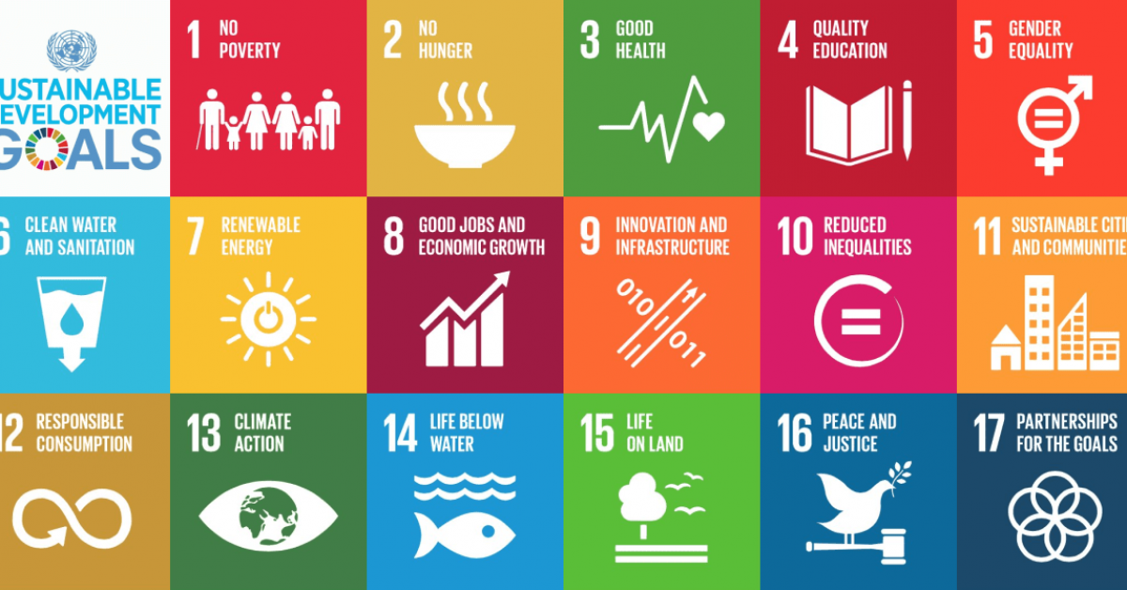  Article 32  You have the right to protection from work that harms you, and is bad for your health and education. If you work, you have the right to be safe and paid fairly.  Article 33  You have the right to protection from harmful drugs and from the drug trade.  Article 34  You have the right to be free from sexual abuse.Article 35No one is allowed to kidnap or sell you.  Article 36  You have the right to protection from any kind of exploitation (being taken advantage of).  Article 37  No one is allowed to punish you in a cruel or harmful way.  Article 38  You have the right to protection and freedom from war. Children under 15 cannot be forced to go into the army or take part in war.  Article 39  You have the right to help if you've been hurt, neglected or badly treated.  Article 40  You have the right to legal help and fair treatment in the justice system that respects your rights.  Article 41  If the laws of your country provide better protection of your rights than the articles in this Convention, those laws should apply.  Article 42  You have the right to know your rights! Adults should know about these rights and help you learn about them, too.  Articles 43 to 54  These articles explain how governments and international organizations like UNICEF will work to ensure children are protected with their rights.

