Year 4 | Maths  White Rose | English  Pathways To Read  Pathways To Write | Science | Computing | Art | DT | Geography | History | Music
 | Autumn  Number – Place Value  Number – Addition and Subtraction  Measurement – Area  Number – Multiplication and Division A | A World Full of Animal Stories: 50 Folk Tales and Legends by Angela McAllister  Gorilla by Anthony Browne  The Train to Impossible Places by P.G. Bell  Leon and the Place Between by Graham Baker-Smith, Oz the Great and Powerful (2013 film) | Working Scientifically  - practical learning at every opportunity | Using Technology Safely | Cultural Understanding through a range of artists | Cultural Understanding – products and structures in the real world | Cultural Understanding – exploring people and places from around the world | Cultural Understanding – exploring people and events that have shaped our world today | Cultural Understanding – listening and appreciating different music from all over the world
 |  |  | Living Things and their Habitats  - classification keys  -changing environments | Computing systems and networks – The internet | Pencil Project  - master pattern and texture techniques through the work of an artist | Carpentry Project  - construct a structure using wood as a frame | Fieldwork  - outdoor learning at every opportunity
 |  |  |  | Creating media – Audio editing
 | Spring  Number – Multiplication and Division B  Measurement – Length and Perimeter  Number – Fractions  Number – Decimals A | Fantastic Forests by The Literacy Company (Set 2)  Our Tower by Joseph Coelho  Ariki and the Island of Wonders by Nicola Davies (Set 1&2)  Wisp by Zana Fraillon (Set 2) | Animals, including Humans  -digestive system  -teeth  -food chains | Data and information – Data logging | Acrylic Project  - explore tint and tones through the work of an artist | Fashion Designer Project  - create a textile product, including developing pattern pieces | Map Work Project  - keys  - grid references  - compass directions | Invaders Project  - Britain’s settlement by Anglo-Saxons and Scots  -Viking and Anglo-Saxon struggle for the Kingdom Of England | Singing in Spanish
 |  |  |  |  |  |  |  |  | Ancient Words
 |  |  | States of Matter  - solids, liquids, gases  - changing states  -water cycle | Programming A – Repetition in shapes | ARTIST FOCUS Andy Warhol Famous American acrylic artist who painted ordinary items | Food Project  Explore calories and nutritional content of food  Plan and prepare a healthy savoury SEASONAL dish |  |  | Recycling
 |  |  |  |  |  |  |  |  | Environment
 | Summer  Number – Decimals B  Measurement – Money  Measurement – Time  Consolidation  Geometry – Shape  Statistics  Geometry – Position and Direction | Fantastically Great Women Who Saved the Planet by Kate Pankhurst/Plastic Pollution by The Literacy Company (Set 1&2)  Where the Forest Meets the Sea by Jeannie Baker & Jungle Explorer by The Literacy Company (Set 1)  A Stage Full of Shakespeare Stories by Angela McAllister  A Stage Full of Shakespeare Stories by Angela McAllister (Julius Caesar) | Electricity  - appliances  - series circuits (lamps and switches)  -conductors and insulators | Creating media – Photo editing | Wire Sculpture Project  - texture form and space through the work of an artist | Electrician Project  - explore and build with bulbs, buzzers and switches | Rivers Project  - Water Cycle  - Rivers | Revolution Project  - focus on a revolutionary person (beyond 1066) Crime and Punishment Victorians Robert Peel | Poetry
 |  |  |  |  |  |  |  |  | Sound
 |  |  |  |  |  |  |  |  | In The Past
 |  |  |  |  |  |  |  |  | Building
 |  |  | Sound  -vibrations  - ear  -pitch | Programming B – Repetition in games | Textile Project  - explore textile techniques through the work of an artist |  | UK Project  - Explore the UK  - key human and physical characteristics | Stevenage Project  - local history study | Time
 |  |  |  |  |  |  |  |  | Around the World
 |  |  |  |  |  |  |  |  | Food and Drink
 |  |  |  |  |  |  |  |  | Communication

Year 4 | RE Herts Scheme  Christianity  Islam  Sikhism | PSHCE  Jigsaw Scheme | Languages SPANISH  Language Angels Scheme | PE  GetSet4PE Scheme  Including Inspirational Sports Athlete
Autumn 1 | Harvest Festivals around the World  Beliefs and Practice – marking festivals, pilgrimage, traditions and key events in life (Harvest)  Ultimate Questions- What is it like to follow God? | Being me in my own world – class charter; being a school citizen | - Phonetics 2  (core vocab)  - Seasons | - Swimming  - Basketball  Tom Daley
Autumn 2 | The Trinity and Christmas  Symbols and Actions – symbolic expression in prayer and worship; exploring the trinity at Christmas – incarnation  Ultimate Questions-  What is the trinity? | Celebrating Difference – first impressions and acceptance | - Vegetables | - Swimming  - Fundamental  Tom Daley
Spring 1 | Different Ideas about God  Identity and Belonging - Belonging to a community, individual commitment and religious leadership  Prayer, Worship and Reflection – Different ideas about God and gods; creation and ultimate questions  Ultimate Questions- What do Christians learn from the creation story? | Dreams and Goals – resilience and setting new goals | - Presenting myself | - Striking and Fielding  - Swimming  - Virtual Athletics  Tiger Woods
Spring 2 | Exploring Good Friday  Beliefs and Practice – communicating through sacred spaces and prayer  Exploring Good Friday – Jesus’ death and resurrection  Ultimate Questions- Why do Christians call the day Jesus died Good Friday? | Healthy Me – peer pressure | - My family | - Tri-Golf  - Swimming  Tiger Woods
Summer 1 | Exploring Light Symbolism  Sources of Wisdom – sacred texts and stories; their guidance and impact  Justice and Fairness – right and wrong, just and fair | Relationships – different points of view | - In the classroom | - Gymnastics  - Invasions Games (Netball)  Andy Murray
Summer 2 | In a perfect world…  Human responsibility and Values – taking responsibility for living together; values and respect  Ultimate Questions- Why do Christians call the day Jesus died Good Friday? What kind of world would Jesus want? | Changing Me - talk about physical differences between males and females as they grow up and how we feel about changes that are out of our control  - I can use scientific vocabulary to talk about the differences in males and females as they grow older (facial hair, pubic hair, breasts, testicles, penis, vagina, hips, shoulders)  - I know that females grow babies and explain how female bodies develop so that they can have babies (uterus, womb, breasts)  - I recognise there are changes that I can control and changes that are out of my control  - I can talk about ways to help me cope with worries about change | - At the café | Athletics  Tennis  Sports day activities  Andy Murray

Rights Respecting School Articles
Article 1  Everyone under 18 has these rights.  Article 2  All children have these rights, no matter who they are, where they live, what their parents do, what language they speak, what their religion is,whether they are a boy or girl, what their culture is, whether they have a disability, whether they  are rich or poor. No child should be treated unfairly on any basis.  Article 3  All adults should do what is best for you. When adults make decisions, they should think about how their decisions will affect children.  Article 4  The government has a responsibility to make sure your rights are protected. They must help your family to protect your rights and create an environment where you can grow and reach your potential.  Article 5  Your family has the responsibility to help you learn to exercise your rights, and to ensure that your rights are protected.  Article 6  You have the right to be alive.  Article 7  You have the right to a name, and this should be officially recognized by the government. You have the right to a nationality (to belong to a country).  Article 8  You have the right to an identity – an official record of who you are. No one should take this away from you.  Article 9  You have the right to live with your parent(s), unless it is bad for you. You have the right to live with a family who cares for you.  Article 10  If you live in a different country than your parents do, you have the right to be together in the same place.  Article 11  You have the right to be protected from kidnapping.  Article 12  You have the right to give your opinion, and for adults to listen and take it seriously.  Article 13  You have the right to find out things and share what you think with others, by talking, drawing, writing or in any other way unless it harms or offends other people.  Article 14  You have the right to choose your own religion and beliefs. Your parents should help you decide what is right and wrong, and what is best for you. | Article 15  You have the right to choose your own friends and join or set up groups, as long as it isn't harmful to others.  Article 16  You have the right to privacy.  Article 17  You have the right to get information that is important to your well-being, from radio, newspaper, books, computers and other sources. Adults should make sure that the information  you are getting is not harmful, and help you  find and understand the information you need.  Article 18  You have the right to be raised by your parent(s) if possible.  Article 19  You have the right to be protected from being hurt and mistreated, in body or mind.  Article 20  You have the right to special care and help if you cannot live with your parents.  Article 21  You have the right to care and protection if you are adopted or in foster care.  Article 22  You have the right to special protection and help if you are a refugee (if you have been forced to leave your home and live in another country), as well as all the rights in this Convention.  Article 23  You have the right to special education and care if you have a disability, as well as all the rights in this Convention, so that you can live a full life.  Article 24  You have the right to the best health care possible, safe water to drink, nutritious food, a clean and safe environment, and information to help you stay well.  Article 25  If you live in care or in other situations away from home, you have the right to have these living arrangements looked at regularly to see if they are the most appropriate.  Article 26  You have the right to help from the government if you are poor or in need.  Article 27  You have the right to food, clothing, a safe place to live and to have your basic needs met. You should not be disadvantaged so that you can't do many of the things other kids can do.  Article 28  You have the right to a good quality education. You should be encouraged to go to school to the highest level you can. | Article 29  Your education should help you use and develop your talents and abilities. It should also help you learn to live peacefully, protect the environment and respect other people.  Article 30  You have the right to practice your own culture, language and religion - or any you choose. Minority and indigenous groups need special protection of this right.  Article 31  You have the right to play and rest.  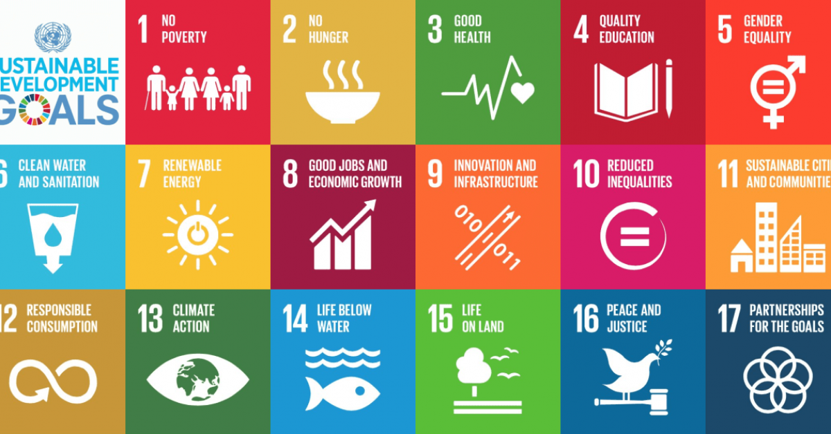  Article 32  You have the right to protection from work that harms you, and is bad for your health and education. If you work, you have the right to be safe and paid fairly.  Article 33  You have the right to protection from harmful drugs and from the drug trade.  Article 34  You have the right to be free from sexual abuse.Article 35No one is allowed to kidnap or sell you.  Article 36  You have the right to protection from any kind of exploitation (being taken advantage of).  Article 37  No one is allowed to punish you in a cruel or harmful way.  Article 38  You have the right to protection and freedom from war. Children under 15 cannot be forced to go into the army or take part in war.  Article 39  You have the right to help if you've been hurt, neglected or badly treated.  Article 40  You have the right to legal help and fair treatment in the justice system that respects your rights.  Article 41  If the laws of your country provide better protection of your rights than the articles in this Convention, those laws should apply.  Article 42  You have the right to know your rights! Adults should know about these rights and help you learn about them, too.  Articles 43 to 54  These articles explain how governments and international organizations like UNICEF will work to ensure children are protected with their rights.

