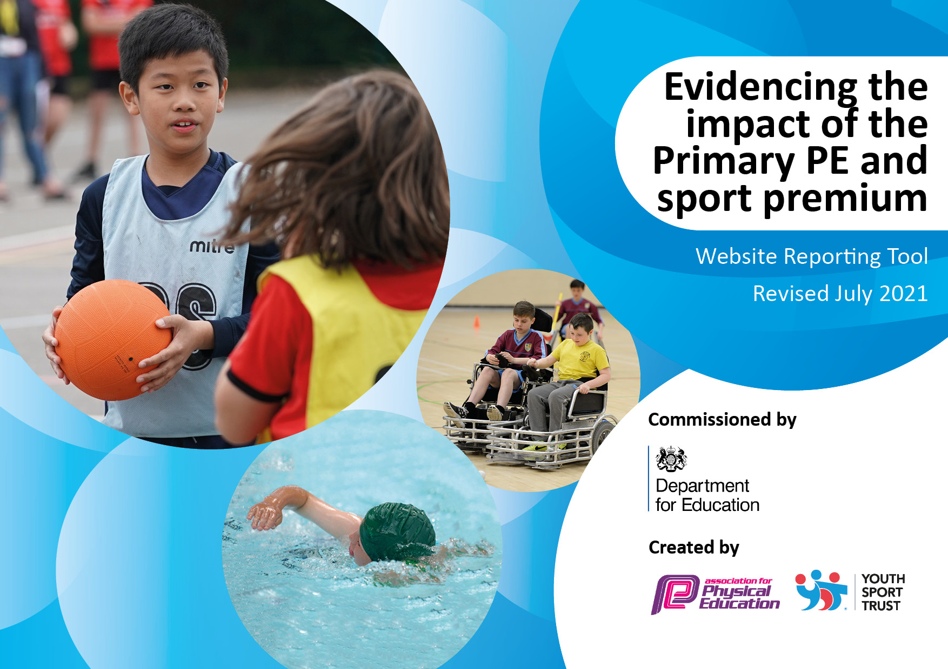
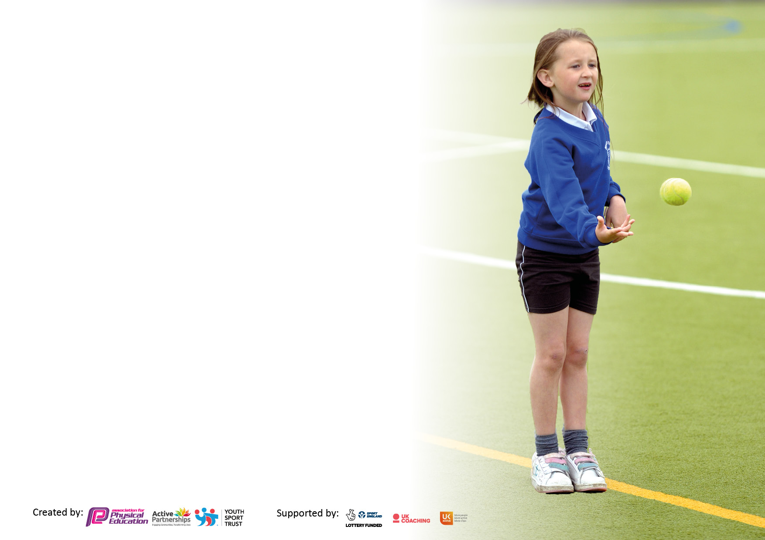

It is important that your grant is used effectively and based on school need. The Education Inspection Framework makes clear there will be a focus on ‘whether leaders and those responsible for governors all understand their respective roles and perform these in a way that enhances the effectiveness of the school’.

Under the Quality of Education Ofsted inspectors consider:
Intent - Curriculum design, coverage and appropriateness
Implementation - Curriculum delivery, Teaching (pedagogy) and Assessment
Impact - Attainment and progress

To assist schools with common transferable language this template has been developed to utilise the same three headings which should make your plans easily transferable between working documents.

Schools must use the funding to make additional and sustainable improvements to the quality of Physical Education, School Sport and Physical Activity (PESSPA) they offer. This means that you should use the Primary PE and sport premium to:

- Develop or add to the PESSPA activities that your school already offer
- Build capacity and capability within the school to ensure that improvements made now will benefit pupils joining the school in future years
- The Primary PE and sport premium should not be used to fund capital spend projects; the school’s budget should fund these.

Pleasevisitgov.ukfortherevisedDfEguidanceincludingthe5keyindicatorsacrosswhichschoolsshoulddemonstrate animprovement.Thisdocumentwillhelpyoutoreviewyourprovisionandtoreportyourspend.DfEencouragesschools to use this template as an effective way of meeting the reporting requirements of the Primary PE and sport premium.

We recommend you start by reflecting on the impact of current provision and reviewing the previous spend.

Schools are required to publish details of how they spend this funding, including any under-spend from 2019/2020, as well as on the impact it has on pupils’ PE and sport participation and attainment. All funding must be spent by 31st July 2022.

We recommend regularly updating the table and publishing it on your website throughout the year. This evidences your ongoing self-evaluation of how you are using the funding to secure maximum, sustainable impact. Final copy must be posted on your website by the end of the academic year and no later than the 31st July 2021. To see an example of how to complete the table please click HERE.

Details with regard to funding
Please complete the table below.

Total amount carried over from 2019/20 | £0
Total amount allocated for 2020/21 | £21,240
How much (if any) do you intend to carry over from this total fund into 2021/22? | £0
Total amount allocated for 2021/22 | £21,240
Total amount of funding for 2021/22. To be spent and reported on by 31st July 2022. | £21,240
Swimming Data
Please report on your Swimming Data below.

Meeting national curriculum requirements for swimming and water safety.  N.B. Complete this section to your best ability. For example you might have practised safe self-rescue techniques on dry land which you can then transfer to the pool when school swimming restarts.  Due to exceptional circumstances priority should be given to ensuring that pupils can perform safe self rescue even if they do not fully meet the first two requirements of the NC programme of study | Water Safety talk delivered to year groups.
What percentage of your current Year 6 cohort swim competently, confidently and proficiently over a distance of at least 25 metres?  N.B. Even though your pupils may swim in another year please report on their attainment on leaving primary school at the end of the summer term 2020.  Please see note above | TBC
What percentage of your current Year 6 cohort use a range of strokes effectively [for example, front crawl, backstroke and breaststroke]?  Please see note above | TBC%
What percentage of your current Year 6 cohort perform safe self-rescue in different water-based situations? | TBC%
Schools can choose to use the Primary PE and sport premium to provide additional provision for swimming but this must be for activity over and above the national curriculum requirements. Have you used it in this way? | No

Action Plan and Budget Tracking
Capture your intended annual spend against the 5 key indicators. Clarify the success criteria and evidence of impact that you intend to measure to evaluate for pupils today and for the future.

Academic Year: 2021/22 | Total fund allocated: £23886 | Date Updated: March 2022
Key indicator 1: The engagement of all pupils in regular physical activity – Chief Medical Officers guidelines recommend that primary school pupils undertake at least 30 minutes of physical activity a day in school |  |  |  | Percentage of total allocation:
 |  |  |  | %
Intent | Implementation |  | Impact
Your school focus should be clear what you want the pupils to know and be able to do and about  what they need to learn and to  consolidate through practice: | Make sure your actions to achieve are linked to your intentions: | Funding allocated: | Evidence of impact: what do pupils now know and what can they now do? What has changed?: | Sustainability and suggested next steps:
- Assessment of fundamental movement skills for children starting in reception and monitored through to the end of Key Stage 1.  - Promote more active movement during the school day  Sport Ambassadors promote being physically active to all chn.  Year 5 Sports Ambassadors promoting mental wellbeing.  National Sports Week  Walk to School Week/  Bike to School Week | Reception Movement Checklist completed in Autumn/ Spring and Summer. Termly targets given out to children to complete at home.  - Teachers all signed up to imoves, the award winning resources to get kids moving no matter what they’re learning.  PE Lead signed school up for ’10 Years of Daily Mile’ event.  - Support on the KS1 playground Support and deliver fitness sessions on KS1/KS2 playground on National Fitness Day.  Create active break videos Young leaders to deliver assemblies throughout the academic year. Help kitchen staff with preparing some of the meals being served at lunch  Deliver virtual assemblies; Just Talk week; HelloYellow and Children’s Mental Health Week  Take part in Mental Health Champions pilot workshop  Supporting in Nile and Jellyfish club  - Fit Kidz workshop  - Tennis Workshop  - Cricket Workshop  - Football Workshop  - Scooter Workshop  - Box Fit  Promote active travel to parents and children. Inform parents about Wow travel tracker.  Create challenge for parents and children  Monitor active travel levels  Liaise with Hertfordshire County Active and Safer Travel Team  Walking Bus during the week | £250 | - Reception teachers and PE lead able to monitor and support those chn struggling with the different activities from the checklist.  - Teacher are using it as brain boosts during learning time. Chn are being more physically active and have a better understanding of their mental well-being and the importance exercise.  - Young sports leaders are trained in leadership skills and are working closely with the younger children. They run clubs and promote sport and fitness across the school. They are promoting being active and leadership skills. Chn help cut up the salad tray and create fruit cocktails to be able to share and encourage others to eat healthy.  - Children promoted mental wellbeing across the school by informing chn of: The 5 ways to wellbeing; importance of being active; healthy eating and sharing the different ways to support your physical and mental wellbeing.  Chn to experience a wide range of activities during this week.  Chn to understand the benefits of active travel. Chn to find enjoyment when coming to school other than by car. | - Sports lead to introduce programme to Key Stage 1 teachers and integrate across the Key Stage. Continue to use Action Mats to build on fundamental movement skills. Continue to develop PE intervention and targets for the children.  - Continue to promote imoves and a The Daily Mile. Continue to liaise with Herts Sport Partnership with events.  -  - Young leaders to have termly meetings in order to plan and deliver high quality sessions with the support of staff where needed.  - Continue to build relationship with local schools to develop children’s understanding of being inclusive in sports and to promote inclusivity in school.  Chn continuing to support in virtual assemblies. Chn to share knowledge from workshop about different ways to help your physical and mental wellbeing.  Continue to promote PESSPA during this week. Engage with more external agencies to help promote PESSPA.  Continue to use Living Streets for information to promote Walk to School Week. Liaise with other external providers to support active travel.
Key indicator 2: The profile of PESSPA being raised across the school as a tool for whole school improvement |  |  |  | Percentage of total allocation:
 |  |  |  | %
Intent | Implementation |  | Impact
Your school focus should be clear what you want the pupils to know and be able to do and about  what they need to learn and to  consolidate through practice: | Make sure your actions to achieve are linked to your intentions: | Funding allocated: | Evidence of impact: what do pupils now know and what can they now do? What has changed?: | Sustainability and suggested next steps:
- An audit of PE equipment undertaken and new resources to be purchased to improve opportunities for children now and in the future.  - Chn experience a range of activities at lunchtime  - Opportunities for disadvantaged children to experience a wide range of sporting activities.  -Youth Sports Trust membership  Afpe Membership  - Football Support & Football League Entered  - Half term Activities  Gain Bronze Modeshift Stars Award for Active Travel | - Audit by sports lead. To include sports equipment for children to use during playtimes  - Playtime Activities rota created to make sure the chn are experiencing a wide range of activities at lunchtime.  - PE lead delivering regular updates and changes with MSA  - Training being delivered to MSA about different activities to help support the children  - Teamwork card as a reward system at lunchtime  - Pupil premium and less active children to be identified by teachers  - Teach Active intervention for PP chn.  - Teach Active Literacy event for Year 3 PP chn  PP chn invited to take part in final part of Travel to Tokyo survey.  To gain regularly information and updates about PESSPA.  To attend any conference and training sessions  To gain regularly information of changes in PESSPA  To attend any conference and training sessions  To look into achieving Quality PE Mark  Children to have regular football activities to continue to support the delivery of girls and boys football.  To train chn and to umpire matches.  - Autumn Half Term Healthy Eating challenge.  - Spring Half Term Growth Mindset challenge  Active Travel Ambassadors (ATA) introduced.  ATA Monitor and support travel tracker.  Support on KS1 playground with scooters at lunch.  Handing out the badges.  Meeting with Hertfordshire Active Travel Advisor  Design a Sleigh Competition  Promoting Anti-Idling  Supporting during Walk to School Week. | -£4000  -£1000  - £210  - £125  - £180  £3000 | - New equipment has enabled many new sports to be taught, such as Sitting Volleyball, New Age Curling and Tri-golf.  - Chn are having a wide range of activities at lunchtime  Children developing teamwork skills  Children and MSA engaging together in PA  - The school is having more success in competitions entered and have won medals in a variety of virtual competitions.  Information is shared with staff members. Useful documents are shared with staff members (Supporting ASD children In PE)  Regular information shared to school about PESSPA  Regular updates/ changes in legislations  Regular CPD information  Regular resources  News letters  Guidance and information about Quality PE mark  Year 5 and 6 girls and boys team entered. Entered a Junior Team (Year 4) for the first time. It has raised the profile of football across KS2. Girls have gained more confidence from year 3 in playing football.  - Children and parents have participate in the activities. Children are being more aware of physical and mental health. Responses from parents have been positive.  - Children and parents are actively travelling to school more. Children want to get a badge and win the trophy for their class. Parents are parking further away from the school which has results in less car traffic. Chn understanding the physical and mental health benefits of active travel. | - Continued monitoring and annual audit of equipment to ensure it is kept to a good standard.  - Pupil voice questionnaire to be shared termly with the Children to discuss their views about PE across the school.  -Gain pupil/teachers and MSA voice about the different activities and changes outside at lunchtime.  Continue to research different activities chn can do.  Look at a range of loose parts that chn can use at lunchtime.  - Continuing to make links with external services in order to provide ongoing opportunities.  Continue to source information to develop PESSPA across the whole.  Continue to use resources to support the delivery of PESSPA  Continue to use the website to support the delivery of PESSPA across the school.  Continue to use to support the delivery of PESSPA.  PE lead to regular attend webinars to keep up-to-date and upskilled in all areas of PESSPA  Use it to gain more information and network with others about the Quality PE Mark  -Continue to take part in Stevenage Schools Football League for boys and girls. Coach will continue to support with umpiring, training and coaching. Continue to use FA Shooting Star- Inspired by Disney resources.  Continue to create activities to promote physical activities for children as well as their families.  - Continue to promote active travel for children and adult. Continue to promote Active Travel in achievement assemblies. Continue to liaise with Hertford County Council Active and Safer Travel Officer to achieve Silver by Easter half term.

Key indicator 3: Increased confidence, knowledge and skills of all staff in teaching PE and sport |  |  |  | Percentage of total allocation:
 |  |  |  | %
Intent | Implementation |  | Impact
Your school focus should be clear | Make sure your actions to | Funding | Evidence of impact: what do | Sustainability and suggested
what you want the pupils to know | achieve are linked to your | allocated: | pupils now know and what | next steps:
and be able to do and about | intentions: |  | can they now do? What has
what they need to learn and to |  |  | changed?:
consolidate through practice:
- Improved quality of children’s PE to ensure they are competent, independent and confident learners.  - Improved role modelling of healthy active lifestyles by all staff to reach all children.  -Look into PE SOW  CPD | - Sports Lead to begin 6 – Professional Vocational Qualifications: Primary School PE Specialism and PE Subject Leadership  - To embed whole school opportunities  - Whole school professional development; including teachers, teaching assistants and lunchtime supervisors.  - Sports lead to provide updates throughout the year during staff meetings.  - Sports lead to observe lessons across the school. Team teaching to be carried out where appropriate.  - Pupil voice to be carried out to discover pupil’s views about PE lessons and their Knowledge and understanding of PE.  - Get Set 4 P.E. SOW brought in to. Giving staff exclusive access to lesson plans, schemes of work, resources, curriculum mapping and assessment, all carefully tailored to each key stage.  Completed Active Lives Survey  NQT and ECT Dance CPD  Virtual Gymnastics CPD  PE lead Dance CPD  OAA Staff Meeting  Teach Active Staff Meeting | -£350  -£300  £660 | - Teachers have received several training sessions which has resulted in increased confidence and improved teaching and learning.  - MSA/TA received virtual training to support the delivery of physical activity during break and lunchtime. Break/lunch time rota created with guided activities for children to take part in. The focus of lessons are child centred and as a result pupils are engaged and are keen to learn and improve. As a result pupils have made good or better progress both in lessons and over time (see teachers' planning and records).  - Teaching assistants working with targeted groups effectively to close gaps.  -Children are more active during the school day. Children have a better understanding of OAA. They are consolidating their knowledge of Maths, English in an active way.  Dance and Gymnastic was and area identifies by PE lead as staff members needing support with. Teachers understanding how to keep lessons simple but effective. | - Sports lead to support new staff in school with planning and delivering PE.  - Arrange team teaching opportunities to develop the quality of teaching, learning and assessment.  - Sports lead to identify staff needing further support and provide appropriate development opportunities.  - Sports lead to monitor the assessment of children to ensure progress and attainment is maintained.  - Increased teacher confidence when teaching tennis or a racket skill.  - Teacher’s response have been positive. It has given teacher different ways to teach in PE. Teacher have the opportunity to engage in CPD by the company. Continue to use the program to support children learning and physical and mental well-being. For teacher to gain confidence when delivering PE.  Continue to monitor and liaise with staff about areas of the NC they would like support with. Liaise with sports partnership about their teacher team teaching opportunities.
Key indicator 4: Broader experience of a range of sports and activities offered to all pupils |  |  |  | Percentage of total allocation:
Intent | Implementation |  | Impact
Your school focus should be clear | Make sure your actions to | Funding | Evidence of impact: what do | Sustainability and suggested
what you want the pupils to know | achieve are linked to your | allocated: | pupils now know and what | next steps:
and be able to do and about | intentions: |  | can they now do? What has
what they need to learn and to |  |  | changed?:
consolidate through practice:
Additional Achievements:  - To increase children’s understanding of water safety by taking part in a range of sporting water events.  - Water Safety  - Commonwealth in Summer Term  - Stevenage Football Club  - Watford Positive Minds Program  (Year 6)  - Children to participate in an extensive list of virtual/ face to face competitions including level 2 and 3 to promote competitiveness and resilience.  Links with a specialist teacher in inclusive PE made to improve inclusive practice.  To increase children understanding of Paralympic sports  - Fit 4 Kidz 6 Week program. Children experienced a range of HITT fitness activities.  -  Fairlands Valley Trip | - Children will be able to take part in a range of water activities using the local lake. Children will understand the basic water safety needs. They will experience a range of different water activities.  - 1decision KS2 program to support the delivery of water safety to all KS2 chn  Water Safety Talk by CommonWealth Athlete  Fairland Valley Water Sports  Child to experience and understand a range of water and outdoor sports activities.  Use commonwealth to promote PA to all chn  Move and Learn’ festival as part of their Health and Wellbeing Day  Positive Minds is the Trust’s mental health and well-being programme that delivers a range of provisions to support; people experiencing poor mental health, the individuals who engage with people with poor mental health, as well as promoting awareness of mental health and useful coping strategies.  - Enter into virtual/face to face competitions delivered by the sporting partnership  • Virtual Archery comp  • Dodgeball Competition  • KS1 Balance Festival  • KS1 Rapid Fire Cricket Festival  • KS2 Rapid Fire Cricket  • KS2 Athletics Competition  Teach Active Literacy Festival Year 3  • Dodgeball comp entered  • Year 3 Development Rugby Event  Freya Levy Commonwealth Paralympic athlete attended school for the day. She delivered a range of Paralympics activities to groups of chn. She delivered and inspirational assembly  Chn develop personal development  Chn try to achieve personal best  Chn experience a range of different fitness activities.  Chn develop perseverance skills  To give more children an experience of Fitness and understand the benefit of a healthy active lifestyle.  - Using local Water Sports Activity Lake. The children experienc; raft building, Pedalo and canoeing. Child to experience and understand a range of water and outdoor sports activities.  - Teacher were able to develop their understanding and knowledge of teaching fitness PE lessons. Children to experience a range of Fitness activities that can be done simply at home.  - | £300  £300  £200  £200  £550 | - The children will learn about water safety. They will learn about the different activities that take place on the water.  - Children to learning and develop their understanding of being safe when around water. Understand the different sings and symbols when around water  Who to call when in danger  Do’s and Don’ts when around water  Chn learn about the different water activities e.g. water polo, diving and Synchronized swimming. They learnt about key aspiration figures.  Chn gain better understanding of competitive sports  Increase chn awareness of British values in sports  Chn to develop in five major areas: physical fitness, motor (bodily) coordination, cognitive functions, creativity (mental reasoning), and life skills.  The programme combines classroom and practical-based activities to engage and increase the awareness around the topic of mental health. The programme covers 10 different topics:  · Introduction to Mental Health  · Coping Strategies and Resilience  · Support Network and Positive Relationships  · Internet Safety & Social Media  · Body Image  · Emotional Literacy & Emotional regulation  · 5 Ways to Wellbeing & Lifestyle  · Body, Mind and Resilience  · Growth Mindset & Transitioning  · Talking about Mental Health  - Children have attended face to face competitions across the year. The competitions are varied and wide and inclusive to all.  - Children have a better understanding of Inclusion and how to make sure everybody is included no matter what race, gender or abilities. Children have thought about ways to adapt their game to include everybody. Continue to build on the different Paralympic sports to give children a better understanding about Paralympic sports and being inclusive.  Chn increased awareness of different activities that can be done to support their physical and mental wellbeing.  Chn develop their confidence in PA  Chn develop their teamwork  - The children have understood a different type of physical activity other than traditional Sports. They are beginning to think about endurance and stamina.  - Children tp understand more about water safety. To learn a range of life skills when in or around water. They developed their teamwork skills.  - Children understood that being physical fit doesn’t mean they have to be part of a sports team. Simple activities can keep them fit and healthy. Developed their understanding of personal best and the School Games Values. | Monitor the success of the current Year 4 children when they complete their swimming provision and Year 3’s.  - Continue to promote water safety talks and events to other year groups. Build links with local swim organisations.  - Liaise with sports partnership  - Research different countries involves  Adopted a Commonwealth theme for sports day  Embed Commonwealth in the summer term  Liaise with SBFC about their Move and Learn program  Continue to build link with large sporting organisations to raise the profile of PESSPA.  - Partnership with SSFT to continue to offer children a variety of competitions to enter throughout the school year.  - To offer a large range of clubs that children are eager to participate in.  - Continue to seek support from Sporting Partnership Inclusion officer. Continue to take part in a range of Paralympic activities.  - .  - Continue to build HITT fitness activities into whole school.  - Continue to build fitness activities into the PE curriculum. Continue to build on personal best challenges.  Continue to use local organisations to support PESSPA

Key indicator 5: Increased participation in competitive sport |  |  |  | Percentage of total allocation:
 |  |  |  | %
Intent | Implementation |  | Impact
Your school focus should be clear | Make sure your actions to | Funding | Evidence of impact: what do | Sustainability and suggested
what you want the pupils to know | achieve are linked to your | allocated: | pupils now know and what | next steps:
and be able to do and about | intentions: |  | can they now do? What has
what they need to learn and to |  |  | changed?:
consolidate through practice:
- An increased participation in the number of sporting events entered. This will include friendly competitions arranged by the sports lead.  - Young leaders to support virtual sporting fixtures/competitions as part of their role of a Sports Ambassador.  - Virtual or league competitions which are facilitated by the SSFT but delivered within schools to offer maximum  participation  - Opportunities for participants in KS1 and KS2 to access events including a range of athletics and competitive sport.  - Monitoring of children across the school who attend a sports competition and after school clubs. | Enter whole school in virtual competitions.  PE Lead to provide training for young leaders. Sports Leaders in Year 4 and 5 to deliver Sports activities and support chn on LKS2 playground. -Young leaders to have half termly meetings in order to plan and deliver high quality sessions with the support of staff where needed.  -Young leaders to delivery assemblies throughout the academic year.  - | - £4500 | - All children in the school have an opportunity to participate in a competitive sport and are developing an interest.  - Virtual Archery Competition  - Dodgeball Competition  - KS1 Balance Festival  - KS1 Rapid Fire Cricket Festival  - KS2 Rapid Fire Cricket  - KS2 Sports Hall Athletics Competition  - KS1 Inclusive Festival  - Year 3 Rugby Development Festival  - Dance Festival  - Quick Sticks Hockey  - Basketball Festival  - Rounder’s Festival  -PE Lead was nominated for Stevenage Pride Award 2021. The Pride of Stevenage Awards celebrate the people, groups and projects that are making great things happen in our communities. They recognise acts of kindness, selflessness and ‘going the extra mile’. | - To continue to enter all competitions available.  - Communicate with other schools to develop competitions for Key Stage 1 children.  - Continue to work with specialist teachers in the delivery of inclusive sporting opportunities.

Signed off by
Head Teacher:
Date:
Subject Leader: | Danika Williams
Date: | 08/03/2022
Governor:
Date:

